**Garmin**min

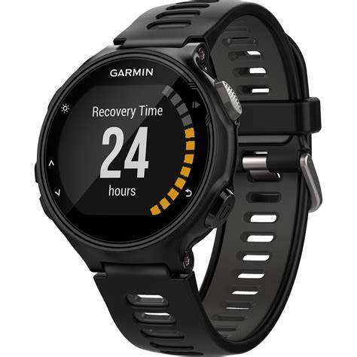 Description: **Garmin** is a well-known brand that offers high-quality smartwatches and fitness trackers designed for active lifestyles. Whether for casual users, fitness enthusiasts, or professional athletes, Garmin provides advanced features such as **GPS tracking, heart rate monitoring, sleep analysis, stress tracking, and SpO2 (blood oxygen) measurement**. The brand is especially popular among women due to models like the **Garmin Lily**, which combines elegance with essential health-tracking features, and the **Garmin Venu 2**, which offers a premium AMOLED display and a variety of sports modes. For runners, the **Garmin Forerunner series** provides detailed performance analytics, while the **Garmin Fenix 7S** is ideal for outdoor adventurers, featuring **solar charging, rugged durability, and topographic maps**. Garmin watches are known for their **long battery life, water resistance, and durability**, making them perfect for both everyday wear and intense workouts. With a strong focus on accuracy and innovation, Garmin continues to be a top choice for those seeking a **reliable, stylish, and performance-driven smartwatch**.